**COLLEGE OF BUSINESS EDUCATION**

**DODOMA CAMPUS**

**A REPORT FOR THE WATER BILLING SYSTEM**

**NAME OF STUDENT: GRACE ELIA NYONGOLE**

**REGISTRATION NO: 03.5025.01.02.2023**

**COURSE: BIT**

**SUBJECT NAME : PROGRAMMING IN JAVA**

**LECTURE NAME: MADAM ATUPELE CAIRO MWAITETE**

**NATURE OF WORK: INDIVIDUAL ASSIGNMENT**

**SUBMISSION DATE: 28TH JANUARY 2025**

**QUESTION**

1. A short report (not more than 10 pages) describing the features implemented, screenshots of the project interface and the challenges faced during the development.

**WATER BILING SYSTEM - PROJECT REPORT**

**1. INTRODUCTION**

The Water Billing System is designed to manage customer registration, login, water usage tracking, billing calculations, and payments. It aims to provide a seamless experience for users to register, track their water consumption, and make payments easily. The system incorporates user authentication, data storage, and billing calculations for efficient water billing management.

**2. OBJECTIVES**

* To create an efficient system for registering users and tracking their water consumption.
* To calculate the total bill based on water usage.
* To allow customers to make payments and view their billing history.
* To save data persistently (user information, billing history).

**3. FEATURES IMPLEMENTED**

**3.1 User Registration**

* Users can register with their name, phone number, location, and address.
* A password is used for secure login.
* Registered users are stored in a file for persistent data storage.
* Data validation is performed to ensure no empty fields during registration.

**3.2 User Login**

* Users can log in using their username and password.
* If login credentials are correct, users are allowed to proceed to the billing screen.
* Incorrect login attempts trigger error messages.

**3.3 Water Usage and Billing Calculation**

* Users enter their water consumption (in cubic meters) and rate per cubic meter.
* The system calculates the total bill by multiplying usage by the rate.
* The total bill is displayed on the screen.

**3.4 Payment System**

* After the bill is calculated, users can proceed to make payments.
* A payment dialog prompts users to enter the payment amount.
* If the payment is sufficient, the system thanks the user and updates their billing history.
* If the payment is insufficient, an error message is shown.

**3.5 Billing History**

* Billing information is saved in a file to maintain a history of payments and usage.

**3.6 Data Persistence**

* User data and billing information are stored in text files (users.txt and billing_history.txt), ensuring the system’s state is retained even after restarting.

**3.7 Error Handling and Validation**

* The system includes input validation, ensuring that only valid numbers are entered for water usage and rates.
* Errors are handled with user-friendly messages displayed using JOptionPane.

**3.8 UI and Layout**

* The user interface (UI) is designed to be simple and easy to navigate.
* The layout consists of a login screen, registration form, and billing screen.
* Images are used for aesthetic appeal and to make the application more engaging.

**4. SYSTEM ARCHITECTURE**

The system uses a simple client-server architecture where the application interacts with local text files for storing and retrieving user and billing data. The UI is designed with JFrame and JPanel components from Java Swing, which manage the registration, login, and billing screens.

**5. SCREENSHOTS OF THE PROJECT INTERFACE**

* **Registration Screen:**
  + Displays input fields for name, phone number, address, and password.
  + Includes a button for submitting the registration form.

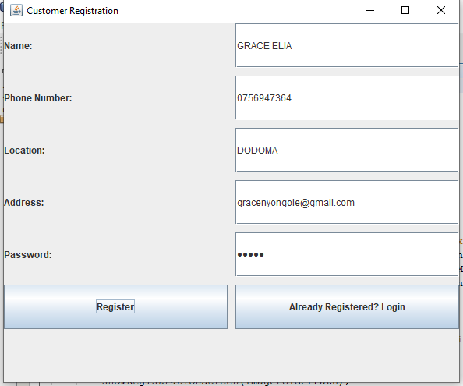

* **Login Screen:**
  + Includes fields for entering the username and password.
  + A button is used to submit the login request.

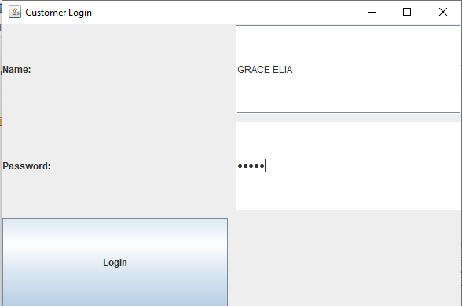

* **Billing Screen:**
  + Displays input fields for water usage and rate per cubic meter.
  + Shows the total bill and buttons for calculation and payment.

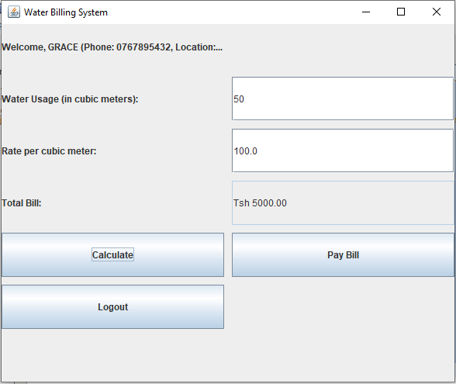

* **Payment Confirmation Screen:**
  + Displays the "Thank You for your payment!" message once the payment is successful.
  + If payment is insufficient, it shows a prompt for the user to input a higher amount.

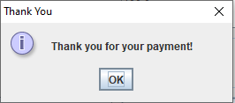

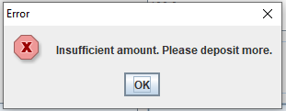

**6. TECHNOLOGIES USED**

* **Java:** For the main application, utilizing Java Swing for building the user interface.
* **Swing:** Used to create graphical user interfaces (GUIs) with JFrame, JPanel, JLabel, JTextField, and other components.
* **File Handling:** The system uses Java’s file-handling capabilities to store user and billing information in .txt files.
* **Event Handling:** Action listeners are used to manage user interactions such as button clicks.

**7. CHALLENGES FACED DURING DEVELOPMENT**

**7.1 Managing Data Persistence**

* One of the initial challenges was implementing data persistence. The user data and billing history needed to be saved in a way that it could be accessed across multiple sessions of the program.
* The solution was to use text files to store this data, which involved learning how to write and read from files in Java.

**7.2 Validating User Inputs**

* Ensuring that the input for water usage, rate, and payment amount were numeric was challenging, especially when dealing with invalid input.
* Input validation was implemented to handle non-numeric values and inform the user when invalid data was entered.

**7.3 UI Design and User Experience**

* The design of a user-friendly interface was another challenge, especially considering that Java Swing can sometimes feel clunky for users used to modern UI design patterns.
* Ensuring all elements were properly aligned, and the flow of the system was logical, required iterative testing and adjustments.

**7.4 Error Handling**

* Properly handling all possible errors, including invalid data input, file I/O issues, and user login failures, was another hurdle.
* By using Java’s JOptionPane for error messages, I was able to ensure that errors were displayed in a user-friendly way, improving the overall user experience.

**7.5 System Testing**

* Another challenge was testing the system, especially ensuring that the billing calculations were accurate.
* Extensive testing was done to ensure that all the features worked correctly, including successful registration, login, usage tracking, bill calculation, and payment.

**8. LESSONS LEARNED**

* Throughout the development of this project, I learned how to integrate data storage, UI components, and event-driven programming.
* Working with file handling in Java gave me a deeper understanding of how data can be stored locally and managed between user sessions.
* I also gained a better understanding of the importance of validation and error handling, which improved the robustness of the application.

**9. CONCLUSION**

The Water Billing System project was successfully developed, meeting the initial goals of providing a seamless user experience for water billing. The system incorporates features such as user registration, login, water usage tracking, and payment management. The challenges faced during development, particularly related to data storage, validation, and UI design, were successfully overcome. This project not only provided practical experience in Java programming but also improved my problem-solving skills in software development.

**APPENDIX**

1. **Code Listing:**
   * Provide the full code listing here.
2. **Additional Screenshots:**
   * Include additional screenshots or any relevant images of the system in use.

**REFERENCE**

Author, A. A. (Year). *Water Billing System* (Version 1.0) [Computer software]. Available from [URL or location where the software is stored, e.g., GitHub repository or file path].